Problem 1: Read the instructions carefully and answer accordingly. If there is any need to insert some data then do that as well.

1. Navigate and List: a. Start by navigating to your home directory and list its contents. Then, move into a directory named "LinuxAssignment" if it exists; otherwise, create it.

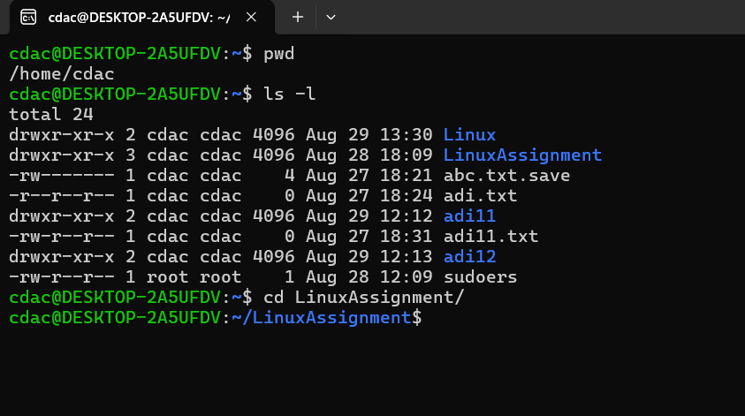

* pwd: This command prints the current working directory.
* Ls -l: This command is used to list all the files in directory with is detailed informatiob.
* cd LinuxAssignment / : This command id the change directorty path command to the LinuxAssignment directory.
* mkdir LinuxAssignment: This command is used to make the directory LinuxAssignment.

b) File Management: a. Inside the "LinuxAssignment" directory, create a new file named "file1.txt". Display its contents.

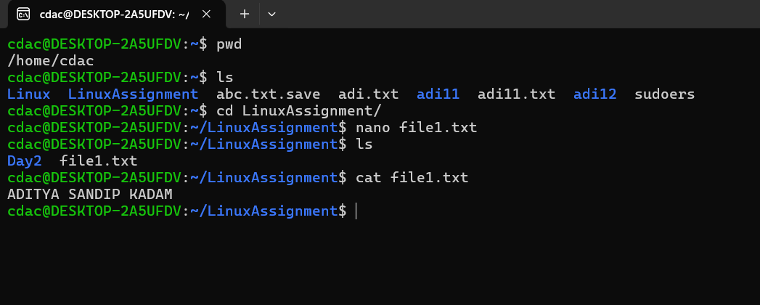

* nano file1.txt: This command actually runs the file and opens it in the editor to make the changes.
* Cat file1.txt: This command actually prints the contents of the file1.txt.

C) Directory Management: a. Create a new directory named "docs" inside the "LinuxAssignment" directory.

* mkdir docs: This command is used to make the directory docs in the LinuxAssignment directory.

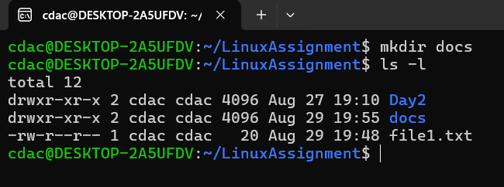

D)Copy and Move Files: a. Copy the "file1.txt" file into the "docs" directory and rename it to "file2.txt".

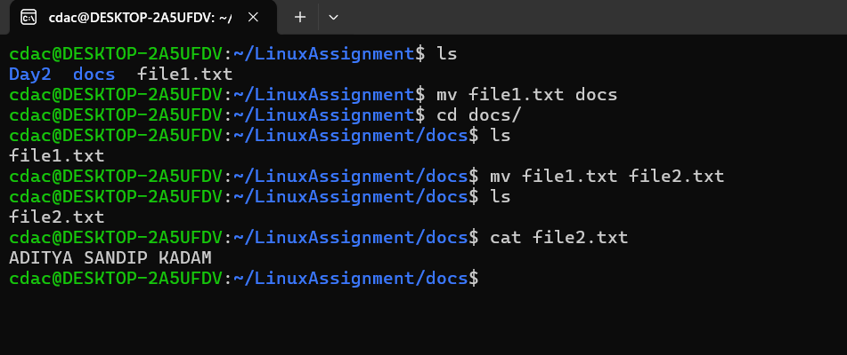

* mv file1.txt docs : This command moves the file1.txt in the docs directory.
* mv file1.txt file2.txt : This command rename the file1.txt to file2.txt
* cat file2.txt : Prints the content of file2.txt on the terminal.

e) Permissions and Ownership: a. Change the permissions of "file2.txt" to allow read, write, and execute permissions for the owner and only read permissions for others. Then, change the owner of "file2.txt" to the current user.

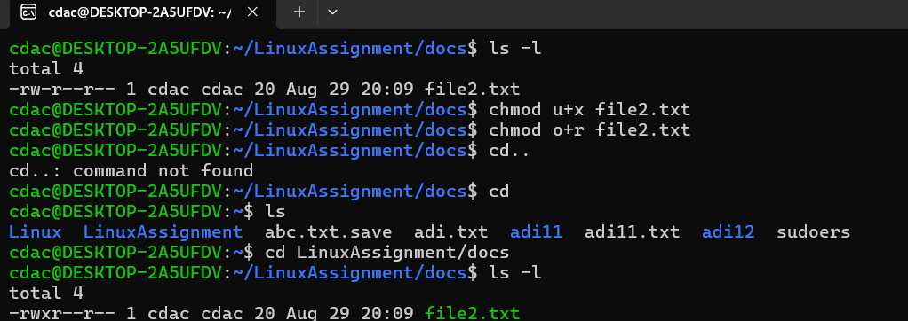

* chmod u+x file2.txt: “u” means user and “x” means execute in this command its use to give permission to user and read and write permissions are given to user by default.
* chmod o+r file2.txt: “o” means others and “r” means read in this command its use to give permission to others .

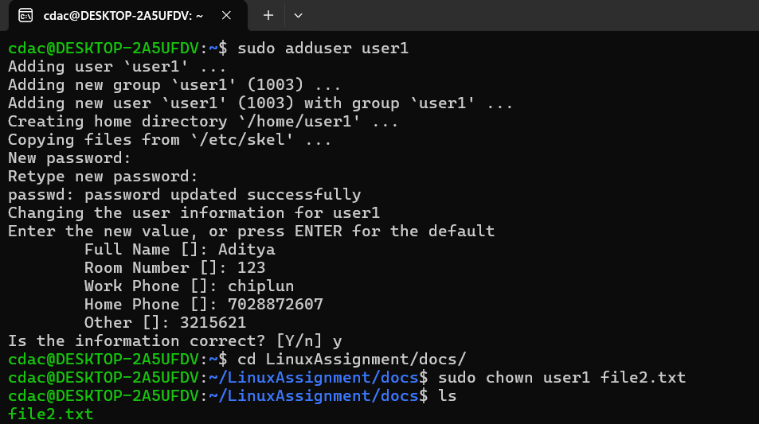

f) Final Checklist: a. Finally, list the contents of the "LinuxAssignment" directory and the root directory to ensure that all operations were performed correctly.

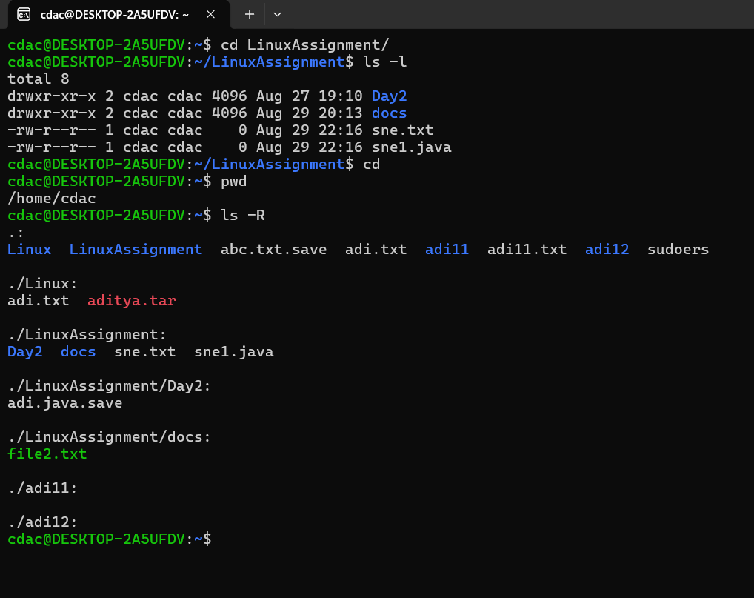

* ls -R:This command is used to list all the files in directories and all its subdirectories .It lists all the directoris ,files and subdirectories.

g) File Searching:

a. Search for all files with the extension ".txt" in the current directory and its subdirectories.

b. Display lines containing a specific word in a file (provide a file name and the specific word to search).

grep -n "Linux" welcome.txt…….

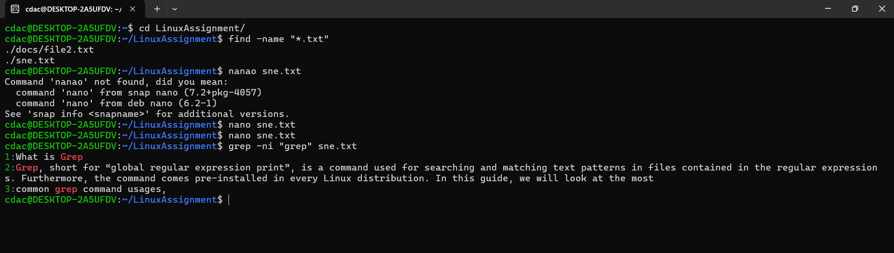

* find -name “*.txt”: This command is used for finding all “.txt “ files int current directory.
* grep -ni “grep” sne.txt : grep command is used with parameters

-n for number of line where word is present and -i for independent to uppercase and lower case finding “grep” word in sne.txt.

h) System Information: a. Display the current system date and time.

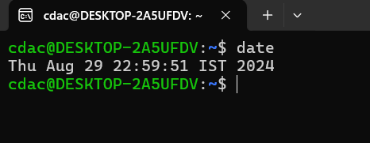

* date : command is used to display the current system date and time.

i) Networking:

a. Display the IP address of the system.

b. Ping a remote server to check connectivity (provide a remote server address to ping).

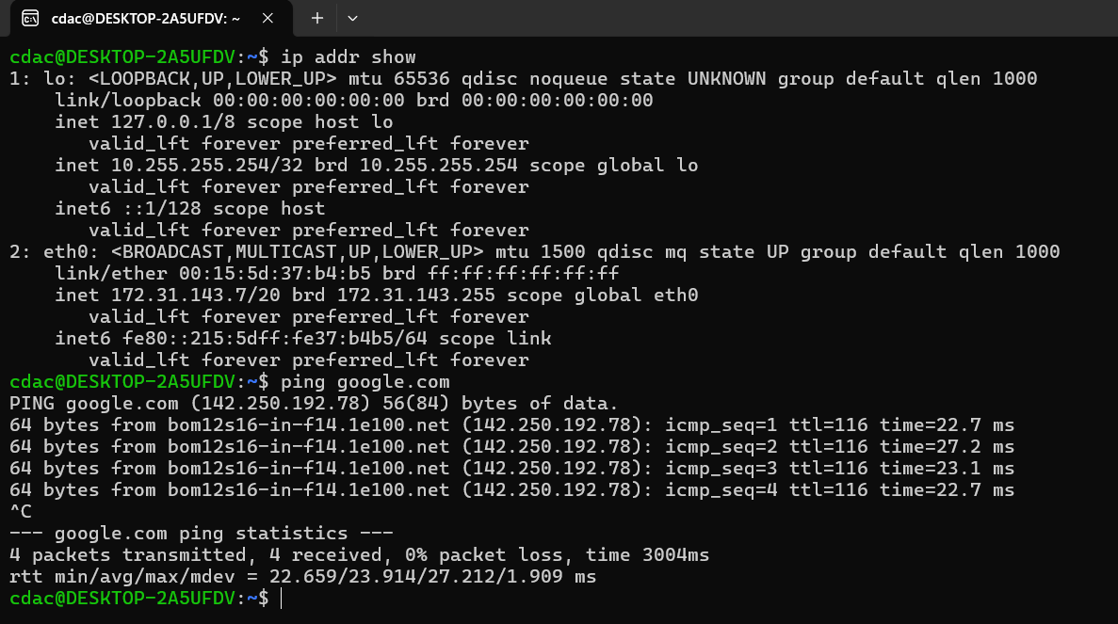

* ip addr show: for showing ip address of a system.
* Ping: provide a remote server address to ping.

j) File Compression:

a. Compress the "docs" directory into a zip file.

b. Extract the contents of the zip file into a new directory

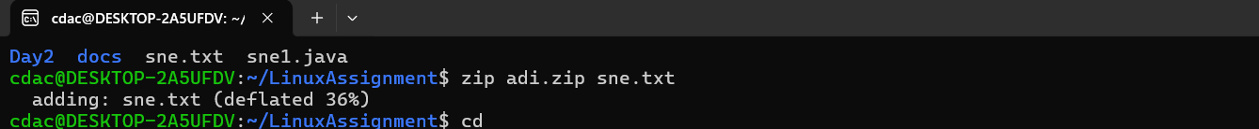

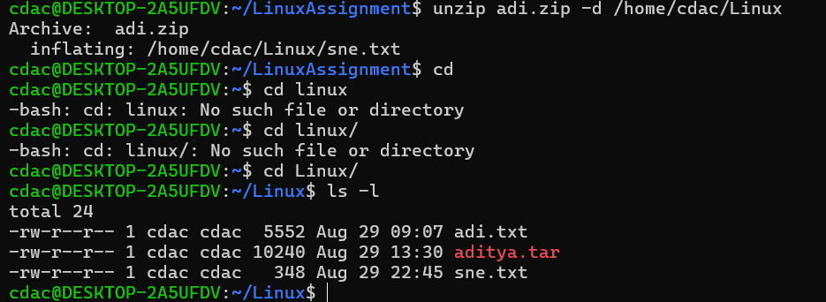

* zip adi.zip sne.txt : In this command adi.zip is a zip file in which sne.txt file is zipped by using this command.
* unzip adi.zip -d /home/cdac/linux :by using this command adi.zip is unzipped and -d is used to give the path of directory where we have to unzip the file.

k) File Editing:

a. Open the "file1.txt" file in a text editor and add some text to it.

b. Replace a specific word in the "file1.txt" file with another word (provide the original word and the word to replace it with).

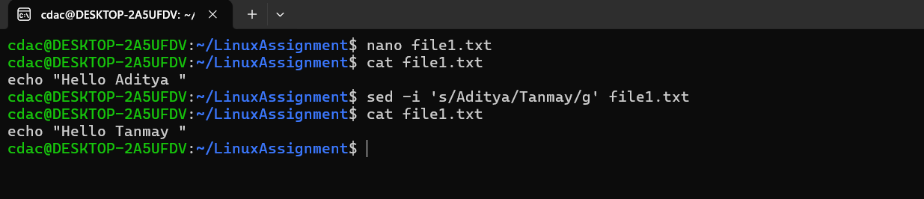

* **sed -i 's/Rahul/Sumit/g' file1.txt :this is used as script editor.**

Problem 2: Read the instructions carefully and answer accordingly. If there is any need to insert some data then do that as well.

1. Suppose you have a file named "data.txt" containing important information. Display the first 10 lines of this file to quickly glance at its contents using a command.

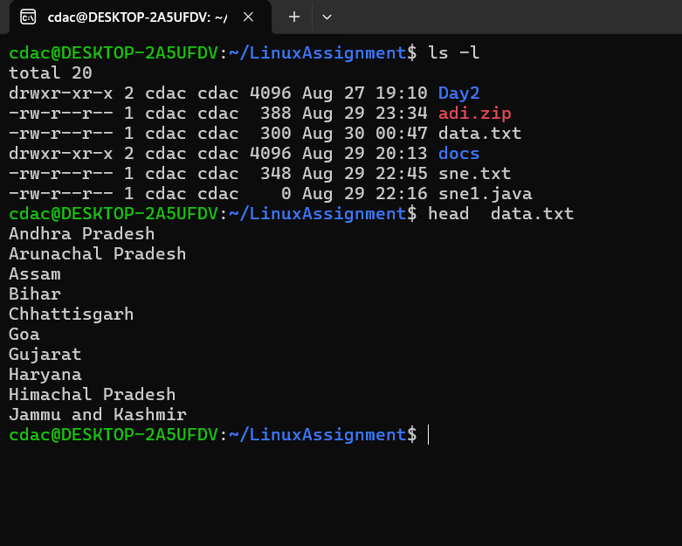

* head data.txt: headis the command used printing the lines from the file and by default prints first 10 lines of a file.

1. Now, to check the end of the file for any recent additions, display the last 5 lines of "data.txt" using another command.

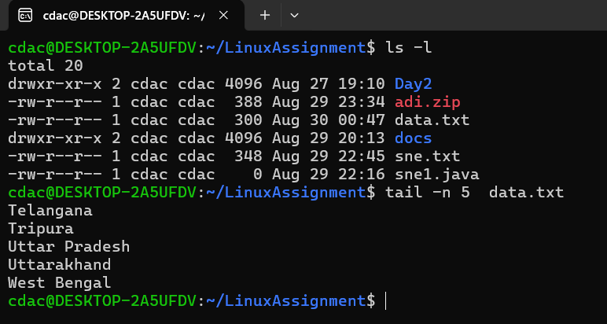

* tail -n 5 data.txt: tailis the command used printing last lines from the file and -n parameter used print number of lines from file.

1. Now, to check the end of the file for any recent additions, display the last 5 lines of "data.txt" using another command.



* tail -n 5 data.txt: tailis the command used printing last lines from the file and -n parameter used print number of lines from file.

1. To focus on the last few numbers of the dataset, display the last 3 lines of "numbers.txt".

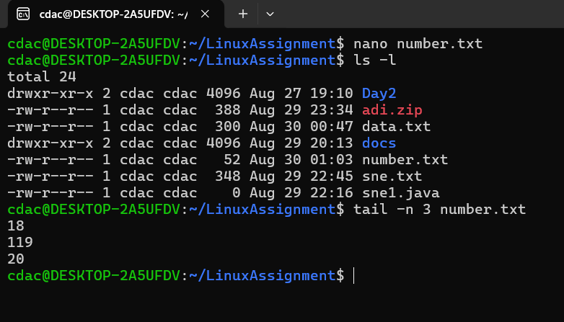

* tail -n 3 data.txt: tailis the command used printing last lines from the file and -n parameter used print number of lines from file.

1. Imagine you have a file named "input.txt" with text content. Use a command to translate all lowercase letters to uppercase in "input.txt" and save the modified text in a new file named "output.txt."

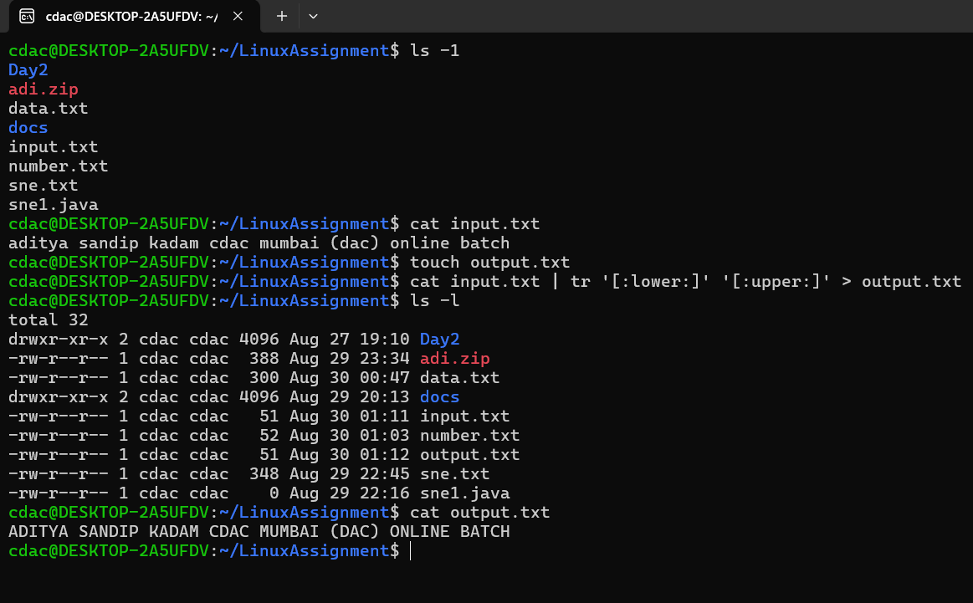

* tr : this is the transform command used to transform it from lower case to upper case.

1. In a file named "duplicate.txt," there are several lines of text, some of which are duplicates. Use a command to display only the unique lines from "duplicate.txt."

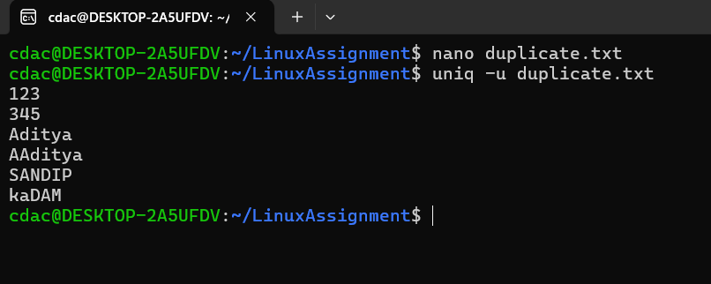

* Uniq -u : is used to print the unique values.

1. In a file named "fruit.txt," there is a list of fruits, but some fruits are repeated. Use a command to display each unique fruit along with the count of its occurrences in "fruit.txt."

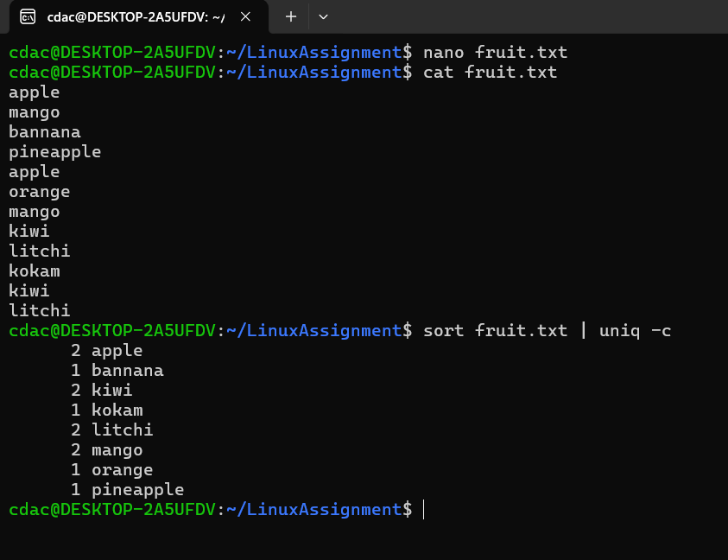

* Sort fruit.txt | uniq -c : sort the file and uniq -c is the parameter used to find the count